SOFTWARE ENGINEERING & WEB DEVELOPMENT LAB MANUAL
PROJECT CASE STUDY: LEDGERLY — INVOICE & QUOTATION GENERATOR PWA

Experiment No. 7: Prepare Use Case Diagram for the Project Topic

1. Pre-Requisites
• Understanding of UML 2.0 behavioral modeling.
• Knowledge of actors (primary, secondary), system boundaries, and associations.
• Proper application of <<include>> (mandatory dependency) and <<extend>> (conditional functionality).

2. Objective
To construct a UML Use Case diagram for Ledgerly representing user roles, system boundary limits, and relationships between core invoicing and accounting operations.

3. Actors & Use Cases
Actor | Role Classification | Associated Use Cases
Business Owner / Freelancer | Primary Actor | Register Account, Login, Manage Profile, Manage Customers, Create Invoice, Record Payment, Download PDF, Export Data.
Client / Customer | Secondary Actor | Receive Invoice, Scan UPI QR, View Account Statement.
Authentication Service | System / Supporting | Validate Credentials (<<include>>), Enforce Session Expiry.

4. Relationships: <<include>> vs <<extend>>
• <<include>> Relationships (Mandatory):
- 'Create Invoice' <<include>> 'Calculate Subtotal, Taxes & Grand Total'.
- 'Login' <<include>> 'Validate Credentials'.
- 'Record Payment' <<include>> 'Recompute Balance Due & Invoice Status'.
• <<extend>> Relationships (Conditional/Optional):
- 'Create Invoice' <<extend>> 'Capture Canvas Digital Signature'.
- 'Preview Invoice' <<extend>> 'Generate Instant UPI QR Code'.
- 'Preview Invoice' <<extend>> 'Dispatch via WhatsApp / Email'.

5. Navigation & Workflow State Machine

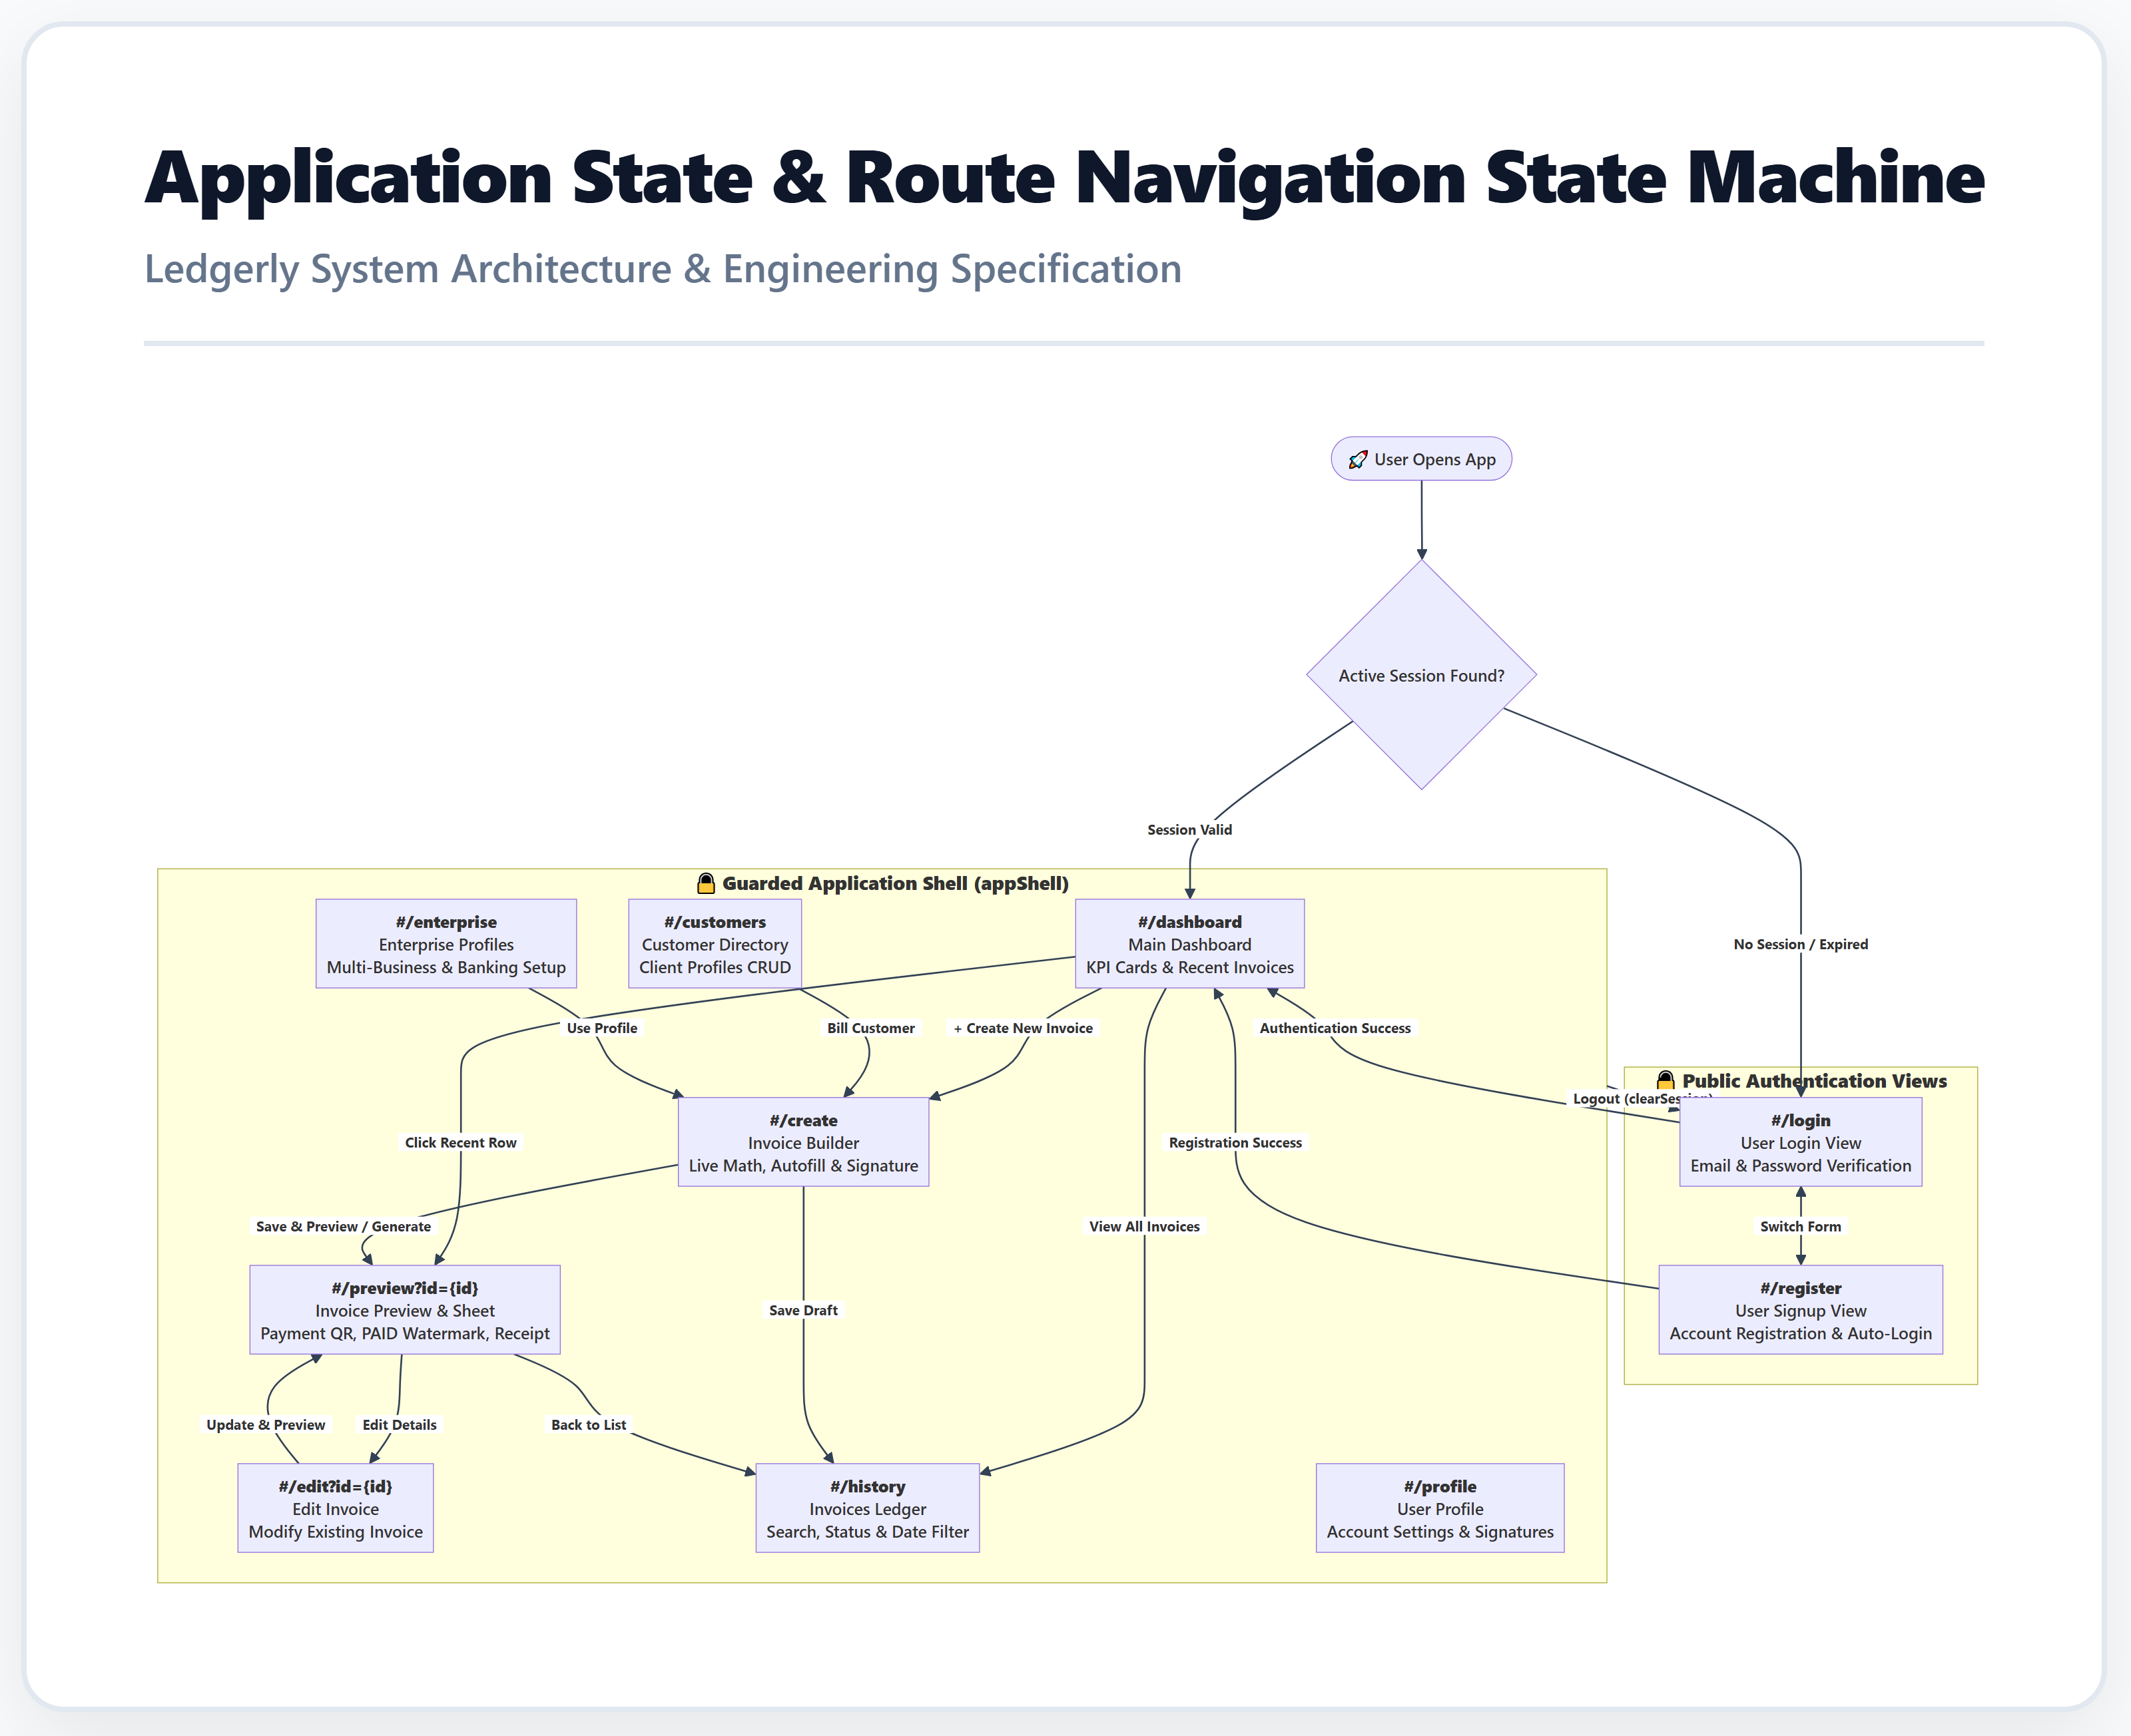
Figure: Route Navigation and Access Guard State Machine

6. Expected Result & Conclusion
The Use Case model defines the functional interactions available to users, establishing unambiguous requirements for the underlying controller logic and event listeners implemented in JavaScript.

